**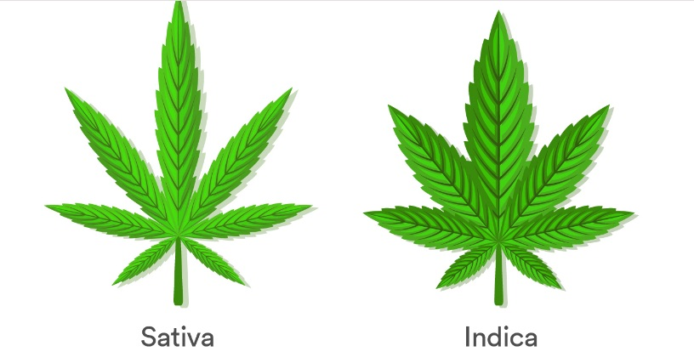**

**Market Segmentation**

* **Cannabis Extract Product Outlook (Revenue, USD Million, 2016 - 2027)**
  + Oils
  + Tinctures
* **Cannabis Extract Type Outlook (Revenue, USD Million, 2016 - 2027)**
  + Full Spectrum Extracts
  + Cannabis Isolates
* **Cannabis Extract Regional Outlook (Revenue, USD Million, 2016 - 2027)**
  + The U.S.
    - U.S. Cannabis Extract Market, by Product
      * Oils
      * Tinctures
    - U.S. Cannabis Extract Market, by Extract Type
      * Full Spectrum Extracts
      * Cannabis Isolates
  + Canada
    - Canada Cannabis Extract Market, by Product
      * Oils
      * Tinctures
    - Canada Cannabis Extract Market, by Extract Type
      * Full Spectrum Extracts
      * Cannabis Isolates
  + Germany
    - Germany Cannabis Extract Market, by Product
      * Oil
      * Tinctures
    - Germany Cannabis Extract Market, by Extract Type
      * Full Spectrum Extracts
      * Cannabis Isolates
  + Italy
    - Italy Cannabis Extract Market, by Product
      * Oil
      * Tinctures
    - Italy Cannabis Extract Market, by Extract Type
      * Full Spectrum Extracts
      * Cannabis Isolates
  + Netherlands
    - Netherlands Cannabis Extract Market, by Product
      * Oil
      * Tinctures
    - Netherlands Cannabis Extract Market, by Extract Type
      * Full Spectrum Extracts
      * Cannabis Isolates
  + Israel
    - Israel Cannabis Extract Market, by Product
      * Oil
      * Tinctures
    - Israel Cannabis Extract Market, by Extract Type
      * Full Spectrum Extracts
      * Cannabis Isolates
  + Australia
    - Australia Cannabis Extract Market, by Product
      * Oil
      * Tinctures
    - Australia Cannabis Extract Market, by Extract Type
      * Full Spectrum Extracts
      * Cannabis Isolates
  + Argentina
    - Argentina Cannabis Extract Market, by Product
      * Oil
      * Tinctures
    - Argentina Cannabis Extract Market, by Extract Type
      * Full Spectrum Extracts
      * Cannabis Isolates
  + Colombia
    - Colombia Cannabis Extract Market, by Product
      * Oils
      * Tinctures
    - Colombia Cannabis Extract Market, by Extract Type
      * Full Spectrum Extracts
      * Cannabis Isolates
  + Mexico
    - Mexico Cannabis Extract Market, by Product
      * Oil
      * Tinctures
    - Mexico Cannabis Extract Market, by Extract Type
      * Full Spectrum Extracts
      * Cannabis Isolates
  + Croatia
    - Croatia Cannabis Extract Market, by Product
      * Oil
      * Tinctures
    - Croatia Cannabis Extract Market, by Extract Type
      * Full Spectrum Extracts
      * Cannabis Isolates
  + Poland
    - Poland Cannabis Extract Market, by Product
      * Oil
      * Tinctures
    - Poland Cannabis Extract Market, by Extract Type
      * Full Spectrum Extracts
      * Cannabis Isolates
  + Czech Republic
    - Czech Medical Republic Marijuana Market, by Product Type
      * Oil
      * Tinctures
    - Czech Medical Republic Marijuana Market, by Medical Application
      * Full Spectrum Extracts
      * Cannabis Isolates
  + Switzerland
    - Switzerland Cannabis Extract Market, by Product
      * Oil
      * Tinctures
    - Switzerland Cannabis Extract Market, by Extract Type
      * Full Spectrum Extracts
      * Cannabis Isolates
  + Uruguay
    - Uruguay Cannabis Extract Market, by Product
      * Oils
      * Tinctures
    - Uruguay Cannabis Extract Market, by Extract Type
      * Full Spectrum Extracts
      * Cannabis Isolates
  + Chile
    - Chile Cannabis Extract Market, by Product
      * Oil
      * Tinctures
    - Chile Cannabis Extract Market, by Extract Type
      * Full Spectrum Extracts
      * Cannabis Isolates

**Report content**

**Qualitative Analysis**

* Industry overview
* Industry trends
* Market drivers and restraints
* Market size
* Growth prospects
* Porter’s analysis
* PESTEL analysis
* Key market opportunities prioritized
* Competitive landscape
  + Company overview
  + Financial performance
  + Product benchmarking
  + Latest strategic developments

**Quantitative Analysis**

* Market size, estimates, and forecast from 2016 to 2027
* Market estimates and forecast for product segments up to 2027
* Regional market size and forecast for product segments up to 2027
* Market estimates and forecast for application segments up to 2027
* Regional market size and forecast for application segments up to 2027
* Company financial performance

Report Overview

The global cannabis extract market size was valued at USD 7.3 billion in 2019 and is anticipated to register a CAGR of 16.6% over the forecast period. The key factors driving this market is the increasing adoption of [medical marijuana](https://www.grandviewresearch.com/industry-analysis/medical-marijuana-market" \t "_blank) for the treatment of chronic diseases like arthritis, Alzheimer’s, and cancer along with mental disorders such as depression, anxiety, and epilepsy. Another factor anticipated to propel the market growth is the rising legalization of medical cannabis in various countries that enables easy access to the patients.

Increasing the adoption of marijuana for medical and recreational purposes has been booming the overall market growth. Legalization of marijuana in some countries has resulted in rising product purchases by legal means thereby, declining its black market sales. Tax charged by the governments is also expected to create revenue generation opportunities for the countries.

To learn more about this report, [request a free sample copy](https://www.grandviewresearch.com/industry-analysis/cannabis-extract-market/request/rs2)

Cannabis oil and tinctures are generally used for treatment of various conditions like psychological disorders, nausea, and cancer. In terms of legality, laws pertaining to extracts are quite lenient due to non-psychoactive properties of Cannabidiol (CBD) oils compared to other products such as buds and resins. Due to their easy consumption in vapor or in the form of gummies and slowly diminishing social stigma of smoking cannabis buds, these products are anticipated to gain momentum and the increase in demand in the forthcoming years.

Rising prevalence of cancer is also a crucial factor expected to drive the market for cannabis extract during the forecast period. According to the World Health Organization (WHO), in 2015, cancer was the second leading cause of deaths worldwide with around 8.8 million deaths globally. Increasing requirement of therapies related to pain management due to growing disease burden of chronic pain is anticipated to drive the medical marijuana market in near future. Moreover, due to age limitations and the exact calculation of dose, kids have prescribed cannabis oils instead of buds.

Report Coverage & Deliverables

PDF report & online dashboard will help you understand:

* Competitive benchmarking
* Historical data & forecasts
* Company revenue shares
* Regional opportunities
* Latest trends & dynamics

Product Insights

The oil segment held the largest revenue share in the cannabis extract market and was valued at USD 4.8 billion in 2019. This segment is anticipated to witness the fastest CAGR over the forecast period. This is primarily due to the increasing medical applications of the product. Tracking the accurate consumption of prescribed dosage that includes Tetrahydrocannabinol (THC), CBD, and other components are crucial. Therefore, the preference for cannabis oils and extracts is comparatively higher as quantifying the accuracy through smoked cannabis.

Marijuana tinctures are consumed sublingually and are prepared by dissolving the drug in alcohol. Tinctures can start working within 15 minutes, which is faster than oils which take around 45 minutes to start working. Therefore, the demand for tinctures is expected to witness significant rise over the forecast period. The tinctures segment is expected to register a CAGR of 14.5% over the forecast period.

Changing perspective of healthcare practitioners regarding safer ingestion techniques such as oral consumption or in the form of beverages or gummies is anticipated to drive the product demand. Majority of producers have started expanding their portfolios in extracts, due to significant demand in end-use industries, such as pharmaceuticals, [nutraceuticals](https://www.grandviewresearch.com/industry-analysis/nutraceuticals-market" \t "_blank), skincare, beverages, and edibles. These products are marketed with specific information on content of TCH and CBD or sole CBD for medical purposes.

Extract Type Insights

In 2019, full-spectrum accounted for the largest revenue share in the cannabis concentrates market and was valued at USD 4.3 billion. This segment is anticipated to register the fastest CAGR of more than 20.0% over the forecast period. The full-spectrum extract includes the complete cannabinoids range that can be extracted from a marijuana plant. There are more than 100 other cannabinoids present in their authentic forms apart from CBD. Due to their availability, full-spectrum extracts produce an entourage effect which is a collaborative relationship between terpenes and cannabinoids that intensifies the healing properties of cannabinoid.

Cannabis isolates are the most reliable forms of their respective cannabinoids and are obtained by isolation and extraction. They have comparatively lesser health benefits than full-spectrum cannabis extracts. Moreover, these isolates retain various advantages resulting in their rising adoption over the years. Their purest form tests negative for THC and possesses no psychoactive effect owing to scarce/no THC content.

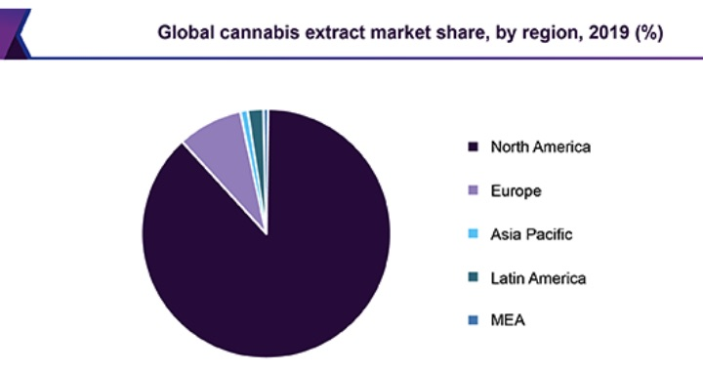

To learn more about this report, [request a free sample copy](https://www.grandviewresearch.com/industry-analysis/cannabis-extract-market/request/rs3)

Due to strict regulations for THC in many countries, the adoption full spectrum or isolates is comparatively low. Physicians are also prescribing the components of medical marijuana owing to its entourage effect. Moreover, the rising pressure of the medical community on the legal bodies to legalize the full spectrum products is anticipated to positively influence the demand for full-spectrum extracts in the future.

Regional Insights

In 2019, North America held the highest revenue share and was valued at USD 6.4 billion owing to higher product adoption and its utilization due to legalization of marijuana in the region. Ten years ago, the legalization was favored by 32% of the overall population and opposed by 60%. In 2018, medical marijuana was legalized in 30 states of the U.S., including Guam, Puerto Rico, and Columbia. According to recent statistics, about 57.0% of adults in the U.S. favor the use of marijuana for medical purposes like the treatment of pain, inflammation, and cancer. Therefore, factors such as legalization of cannabis, increasing support of the citizens, and rising product adoption for medicinal purposes will boost the regional market growth.

In 2019, Europe accounted for the second largest revenue share. Italy is regarded as the fourth largest consumer of cannabis oil and concentrates. However, the legalization in European countries, accompanied by stringent rules and regulations regarding the sale and cultivation, may limit the overall growth in Europe and in turn for the global market. Other promising markets for marijuana are Australia, Germany, Poland, Colombia, Uruguay, and Israel.

Israel is anticipated to exhibit a CAGR of 34.4% from 2020 to 2027, making it a highly profitable market over the forecast period. Factors, such as innovation, increased research activity, a well-developed ecosystem, and liberal government policies are attributing to this growth. The government invested around USD 2.13 Million in January 2017 in 13 different research projects in order to study the effect of cannabis on conditions like rejection of transplanted organ and metabolic syndrome. Increasing R&D investments is also anticipated to increase the market of medical marijuana over the forecast period.

Cannabis Extract Market Share Insights

Aphria Inc.; Canopy Growth Corporation; Aurora Cannabis; Maricann Inc.; Organigram Holdings Inc.; The Cronos Group; and TilrayTikun Olam, Ltd. are the major players that are operating in the cannabis market. These players have established strategic partnerships with extractors and other parties in the value chain to significantly strengthen their market position. Canopy Growth Corporation, for instance, partnered with Danish Cannabis ApS and marked a new joint venture called Spectrum Denmark ApS. This venture aims at strengthening the foothold of the company in the European market.

Report Scope

|  |  |
| --- | --- |
| **Attribute** | **Details** |
| Base year for estimation | 2019 |
| Actual estimates/Historical data | 2016 - 2018 |
| Forecast period | 2020 - 2027 |
| Market representation | Revenue in USD Million and CAGR from 2020 to 2027 |
| Country scope | U.S., Canada, Germany, Italy, Netherlands, Croatia, Poland, Czech Republic, Switzerland, Australia, Uruguay, Colombia, Mexico, Chile, Argentina, and Israel |
| Report coverage | Revenue forecast, competitive landscape, growth factors, and trends |
| 15% free customization scope (equivalent to 5-analyst working days) | If you need specific information, which is not currently within the scope of the report, we will provide it to you as a part of customization |

Segments Covered in the Report

This report forecasts revenue growth at country levels and provides an analysis of the latest industry trends in each of the sub-segments from 2016 to 2027. For the purpose of this study, Grand View Research, Inc. has segmented the global cannabis extract market report on the basis of product, extract type, and country:

* **Product Outlook (Revenue, USD Million, 2016 - 2027)**
  + Oils
  + Tinctures
* **Extract Type Outlook (Revenue, USD Million, 2016 - 2027)**
  + Full Spectrum
  + Isolates
* **Country Outlook (Revenue, USD Million, 2016 - 2027)**
  + The U.S.
  + Canada
  + Germany
  + Italy
  + Netherlands
  + Israel
  + Australia
  + Argentina
  + Colombia
  + Mexico
  + Croatia
  + Poland
  + Czech Republic
  + Switzerland
  + Uruguay
  + Chile